 | 12 ATAR Physics  EM1 Test 2016
  Student name:

1. The diagram shown represents a conductive bar connected to an external potential difference. Draw clearly ON THE DIAGRAM, the induced magnetic field produced when the circuit is closed. (1 mark) | 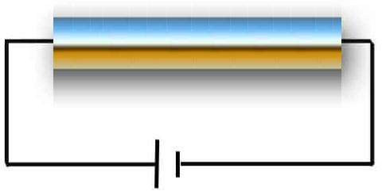

2. The diagram shown represents a current carrying conductor.  - Sketch clearly ON THE DIAGRAM, the magnetic field lines produced by this current when a current is flowing. (1 mark) | 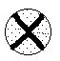

- The conductor is now placed into a magnetic field as shown. A pocket compass is placed at position (A) and then position (B). Sketch (below) the direction of the compass arrow for each position. (2 marks) (Note: B_{earth} = B_{wire}) | 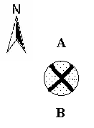
  Position A | Position B

3. A single piece of copper wire is wound into a coil as shown. Draw clearly ON THE DIGRAM, the magnetic field produced when a current (I) is passed through this coil. (3 marks) | 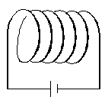

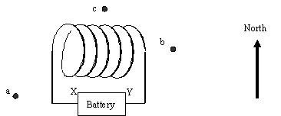

4. The coil shown is connected to the battery terminals X and Y. A compass needle that normally points north has the following orientations when placed in different positions: (2 marks)

 | Position | Orientation
 | a | Points North East
 | b | Points North East
 | c | Points West

Which of the following conclusions is NOT supported by the observations?

- The battery is delivering a current
- X is negative and Y is positive
- The end of the coil near point b is a north pole
- Y is negative and X is positive

5. Power cables run on a pole to a farm in the NE direction.  - Consider the magnetic field produced when a current flows in the wires. Show clearly ON THE DIAGRAM, the direction of the force acting each wire. (2 marks) | 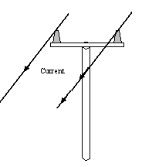

- Explain your answer to part (a). A full explanation will include a diagram and description making use of the RH screw and RH palm rules. (4 marks)

6. When the apparatus shown here is connected to a power supply the conducting wire swings out as shown.  Show clearly ON THE DIAGRAM, the direct of the permanent magnetic field (B), the current (I) and the polarity of the power supply (+/-). (3 marks) | 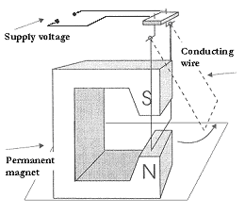

7. Two ions Y and Z of the same velocity are fired into a magnetic field shown going into the page. Which of the following statements is true? (1 mark) | 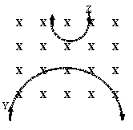

- The magnetic field (B) must be changing with time
- Y and Z are both positively charged
- Y is negatively charged and Z is positively charged
- The magnetic field (B) does no work on Y and Z

8. When a current-carrying wire is placed in a magnetic field the two fields interact to form a newly-shaped resultant field. ON THE DIAGRAM, carefully draw the resultant magnetic field. (2 marks) | 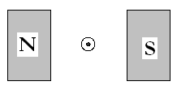

9. When charged particles interact with a uniform magnetic field (B) the resulting path shows particle taking a circular trajectory.

a. Explain why this happens. (2 marks)

b. Show that for a charged particle (q) entering a magnetic field (B) with initial velocity (v), the radius of the orbit of rotation inside the field is directly proportional to the initial velocity (v). (3 marks)

c. When a proton enters a region of uniform magnetic field its path is recorded on the surface of a photographic plate and displayed as the diagram shown here.  1. Indicate the direction of the magnetic field that the proton passes through. (1 mark)  2. Explain why the path of the particle does not remain a circle of constant radius? (2 marks) | 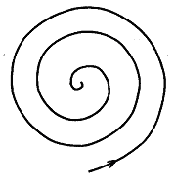

d. How would the path of the particle differ if the particle was an electron with the same speed instead of a proton? (3 marks)

10. In a mass spectrometer, charged particles of varying masses and velocity are accelerated across a pd as shown in the diagram (S1). They then pass through a combination of an electric field and magnetic field to filter their velocities (S2).  a. Explain how the velocity filter works; use equations in your answer. (3 marks) | 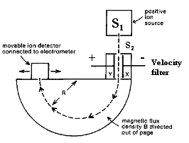

b. The two isotopes of Bromine have relative atom masses of 79.918 and 80.916. If after passing through a mass spectrometer like the one above, the lighter isotope has a radius of curvature of 55.5 mm, find the distance that the detector would have to be moved in order to detect the other ion? (Assume that the ion has the same velocity and charge). (5 marks)

11. The diagram shown opposite gives the general layout of a common circuit breaker.  a. On the diagram, identify the soft iron core. (1 mark)  b. Explain the purpose and physics of the soft iron core (4 marks) | 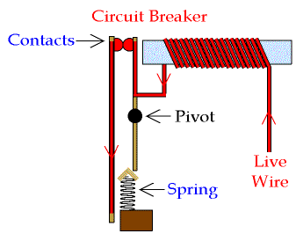

c. A student remarks that using a stainless steel core instead of a soft iron core might actually prolong the life of the circuit breaker as it would reduce failure due to corrosion. Comment on this statement. (2 marks)

e. Explain how the circuit breaker actually works. (4 marks)

13. The diagram shown here represents the basic parts of a DC motor.  a. In which direction will the motor rotate when the current is allowed to flow in the loop PQRS? (1 mark)  b. Two of the key components are labelled A and B, name these parts. (2 marks) | 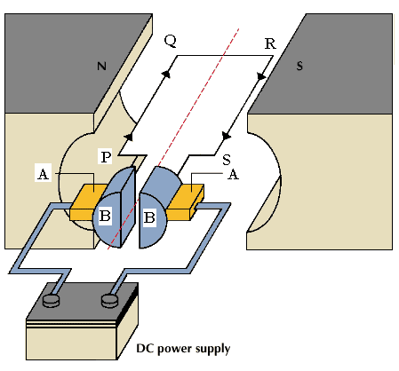

c. In practice, how could this motor be made to spin faster? (1 mark)

d. How could this motor be made to spin more consistently? (1 mark)

e. Given that length PQ is 50 cm, length QR is 40 cm, the magnetic field is 0.35T and the current flowing is 0.75 amps, what would the maximum torque that could be provided by this motor? (4 marks)

f. In the space provided below draw a graph of torque versus period for arm RS. Note: The diagram on page 7 shows the coil at t =0. (3 marks)

g. In detailed steps, explain the physics of the operation of this DC motor.
(5 marks)

